Ideas regarding the submitted sites consultation of the Emerging North Hertfordshire Local Plan

Each parcel is briefly described below with the summary based upon the criteria which are set in North Herts call for sites. For clarity these are set out in italics.

SECOND DRAFT
Site Name | ID | Proposed  Use | Area | Location (scale varies. Image is to show location only)
Land North of Hinxworth Road, Ashwell SG7 5PJ | 48870 | Residential | 2.84 ha | 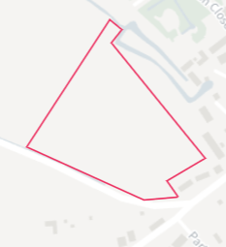
Initial Observations: The parcel currently lies outside of the settlement boundary of Ashwell and borders the Ashwell Conservation Area to the south and east. Hinxworth Road has a rural character and forms the southwestern boundary of the parcel. The parcel is currently actively farmed and forms part of a larger field which extends to the track which links Hinxworth Road to Loves Lane. This parcel is the most distant from Ashwell and Morden Station (over 2 miles away) so would be unsustainably reliant on car usage.

No apparent Biodiversity objection

No apparent objection on flooding grounds

Suggest object on Heritage grounds as it borders the Ashwell Conservation Area to the south and east and forms part of the rural approach to Ashwell. Currently this parcel offers rural views from Newnham Hill towards the east and frames the longer view of St Mary’s Grade 1 listed Church. The following listed buildings are close to the eastern boundary:
Westbury, Westbury Farmhouse and Granary 31, 39 and 41 West End
Barn Range at West End.

Suggest object on Highways grounds as the parcel is to be served off Hinxworth Road which has a rural character and limited capacity. The parcel sits above the road with no footpath connections into the village. Pedestrian access to a footpath on West End would require crossing the busy West End road which has limited visibility.

No apparent objection on infrastructure.

Suggest cumulative impacts not relevant.

Conclusion: suggest object on the harm to landscape character; the rural nature of the Hinxworth Road; harm to village character; poor suitability for safe pedestrian access to the village and location heavily reliant on car usage to access Ashwell & Morden station so not consistent with sustainability objectives.

Dixies Meadow, High Street, Ashwell SG7 5NS | 48569 | Residential | 1.32 ha | 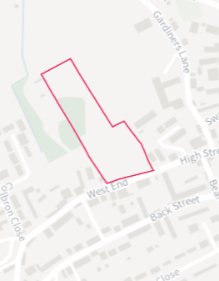
Initial Observations. The parcel currently lies outside of the settlement boundary of Ashwell with the southeastern part of the parcel falling within the Ashwell Conservation Area. The southern boundary borders the High Street with the Grade II listed building of Dixies Farmhouse and Dixies on the opposite side of the Road. There are views through the parcel to the Grade I listed St Mary Church. There are also open views through the parcel to the countryside beyond.

The parcel is currently sheep grazed pasture and is occasionally used for informal parking for village events, such as Ashwell at Home.

No apparent Biodiversity objection

Suggested objection on Flooding grounds as the southern part of the parcel, which borders the High Street, is in the flood zone and so would require housing in this part of the parcel to be elevated above the existing ground level. The northern half of the site is also at Medium to High risk of surface water flooding: https://floodriskmap.co.uk/

Suggested objection on Heritage grounds as the southern part of the parcel falls within the Ashwell Conservation Area with the open farmland within the parcel linking to the Grade II Dixies Farmhouse on the opposite side of the High Street. Close proximity to listed buildings 82, 77, 105 (The Old Cottage), 110 (Woodlands) in the High Street; 1, 5, Barn adjoining 4 and 25 West End. This makes the parcel, and the northern part in particular, a highly sensitive part of the Conservation Area.

No apparent objection on Highways grounds.

No apparent objection on infrastructure.

Suggested objection on Cumulative Impacts as development would close a gap which allows the historic core of Ashwell to have a connection to the rural landscape to the north. It would also harm the setting of Dixies Farmhouse and its connection to the rural landscape.

Conclusion: suggest object on the harm to landscape character; the relationship of the parcel to Dixies Farmhouse; the link between the High Street and the rural landscape to the north; and harm to the Conservation Area.

Land and buildings at 41 West End, Ashwell, SG7 5PL | 48865 | Residential | 0.75 ha | 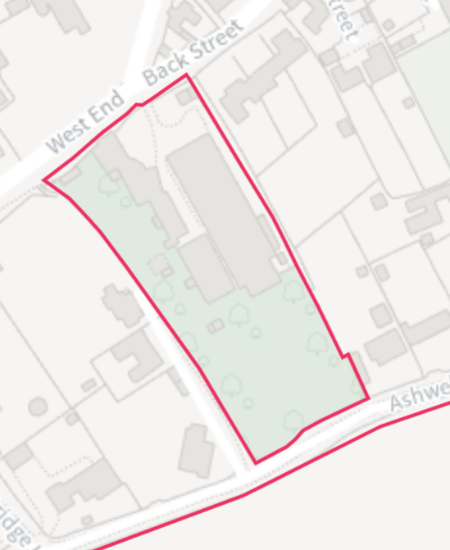
Initial Observations

The parcel is in part previously developed land and contains a former factory building which is of a utilitarian appearance. It also contains the Grade II listed Orchard and is located at the junction of West End and Back Street. The land to the rear of the property contains a number of trees. The parcel lies within the settlement boundary of Ashwell with the frontage of the parcel falling within the Conservation Area. It is well related to the village with existing development on three of its four boundaries.

No apparent Biodiversity objection subject to the trees of value to the rear of the property retained in an appropriate manner.

No apparent objection on Flooding

No apparent objection on Heritage grounds subject to the scale and location of the development having due regard to the Grade II Listed Building of the Orchard which falls within the red line boundary and the interface with the Conservation Area. This parcel is close to listed buildings (41 West End is listed and on the corner of the site) but currently well screened by trees and vegetation. Should development take place this should be retained, and the orchard likewise to prevent serious harm to the setting in the conservation area.

No apparent objection on Highways grounds subject to a satisfactory access being agreed with the Local Authority. In order to be satisfactory, access must not potentially cause significant harm to the character of the setting, in addition to technical highways requirements.

Existing infrastructure could accommodate a small-size development.

Cumulative impacts are not considered an issue.

Conclusion: suggest support subject to the provision of an appropriate highways access and the scale of development not resulting in harm to the setting of the Grade II Orchard and the Ashwell Conservation Area.

Land between Claybush Road and Partridge Hill, Ashwell | 49045 | Residential | 18.51 ha | 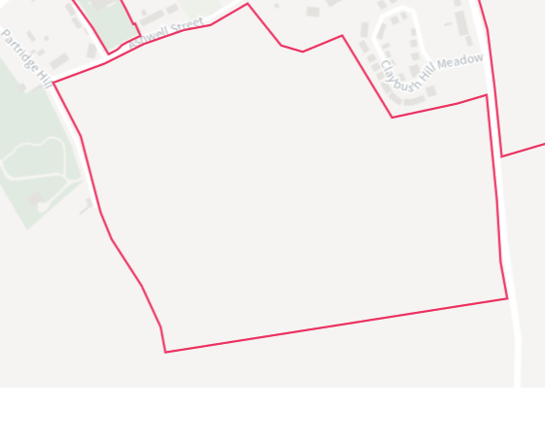
Initial Observations: This is a very large parcel of mainly actively farmed land on the southern hillside close to the crest of Claybush Hill. If only 65% of it were developed for residential, at 35 dph (dwellings per hectare - medium density), it would provide approximately 420 dwellings. Based on an average household occupancy of 2.4 persons per household this would give rise to approximately1,000 new residents. It would occupy part of a much larger field which currently has no southern boundary defined by any features, such as established hedgerows etc.

The southern boundary of the parcel would be approximately 10 metres higher than the southernmost edge to the recent Claybush Hill Meadow development that is well contained by established vegetation. If development were to take place it would significantly extend the village up the valley side and be at odds with the prevailing character of the village which occupies the base and lower slopes of the valley. It would also visibly conflict with the protected setting of Arbury Banks. Claybush Road, which forms the eastern boundary of the parcel, is a rural road and clearly would not have the capacity to accommodate the scale of development proposed. Similarly, the roads within the village would not have the capacity to accommodate the traffic that would be generated from this major development.

No apparent Biodiversity objection

No apparent objection on Flooding grounds

Suggest objection on Heritage grounds as development on the parcel would adversely impact on the setting of Arbury Banks and would also result in indirect effects on the historic core of Ashwell and the Conservation Area.

Suggest objection on Highways grounds as Claybush Road, Ashwell Street and, above all, Bear Lane and Kingsland Way do not have the capacity to support such a development either for vehicles or pedestrians, and similarly the highways infrastructure in the village would not be able to accommodate the scale of development proposed. Connection southward to the A505 is compromised by the narrow road with poor sight lines. No suitable alternative access point to the parcel for vehicles. poor suitability for safe pedestrian access to the village and location heavily reliant on car usage to Ashwell & Morden station so not consistent with sustainability objectives.

Suggest objection on infrastructure grounds as there are not sufficient facilities within the village to accommodate a development of this scale. A second primary school would have to be built to accommodate the education needs of the extra population. Significant upgrades of water supply and sewerage treatment may be required.

Suggest objection on Cumulative Impacts because if this development were to come forward with any other development in the village, Ashwell’s historic character would be fundamentally undermined.

Conclusion: Suggest strong Objection. Based on direct and indirect landscape and visual effects; its unsustainable location; weak highways infrastructure; and significant harm to the historic character of the village. The core transit routes through the village would not be able to sustain the extra vehicles arising out of such a large development. Current village facilities would be overwhelmed by additional population from such a significant development. Development on this parcel would conflict with the NHDC Landscape Character Area Assessment 224 which was adopted to preserve and protect the North Baldock Chalk Uplands in and around Ashwell.

Land to the rear of Scarp Close, Ashwell Street, SG7 5FP | 48981 | Residential | 6.66 Ha | 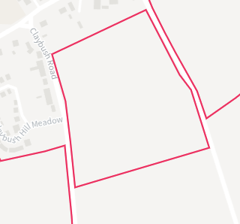
Initial Observations: This parcel forms part of a large, rectangular field of farmland, which is actively farmed. The land rises from approximately 70m AOD on its northwestern boundary to approximately 80m AOD on its southeastern boundary. The land then continues to rise to the summit of Claybush Hill which is at 100m AOD. Given its topography and the lack of any definitive boundary on its on southern edge, the parcel reads as part of the wider undulating landscape and is clearly visible in both long, middle, and near distance views. If development were to take place it would significantly extend the village up the valley side and be at odds with the prevailing character of the village which occupies the base and lower slopes of the valley. It would also visibly conflict with the protected setting of Arbury Banks. Both Claybush Road and Kingsland Way, which border the parcel to the west and east respectively, have a rural character. Similarly, the roads within the village would not have the capacity to accommodate the traffic that would be generated from this major development.

No apparent Biodiversity objection

No apparent objection on Flooding grounds

Suggest objection on Heritage grounds as development of this scale on a prominent location would result in harm to the historic character of Ashwell. Approaching Ashwell from Kingsland Way one can clearly see the Grade One listed St Mary’s Church framed by this field in the foreground. That view would be irrevocably lost by development on this parcel. The traffic that would be generated would also result in an indirect effect on the Conservation Area.

Suggest objection on Highways grounds as Claybush Road does not have the capacity to support such a development, either for vehicles or pedestrians, and similarly the highways infrastructure in the village would not be able to accommodate the scale of development proposed. Connection southward to the A505 is compromised by the narrow road with poor sight lines. The location is heavily reliant on car usage to Ashwell & Morden station so not consistent with sustainability objectives.

Suggest objection on Infrastructure grounds as there are not sufficient facilities within the village to accommodate a development of this scale. The current primary school does not have the capacity and cannot be extended further on its site to provide the education needs of the extra population. Significant upgrades of water supply and sewerage treatment may be required.

Suggest objection on Cumulative Impacts because if this development were to come forward with any other development in the village, Ashwell’s historic character would be fundamentally undermined.

Conclusion: Suggest strong Objection as the location and scale of development would result in significant harm to the character of the village and the wider landscape. The core transit routes through the village would not be able to sustain the extra vehicles arising out of such a large development. Current village facilities could be overwhelmed by additional population from such a significant development. Development on this parcel would conflict with the NHDC Landscape Character Area Assessment 224 which was adopted to preserve and protect the North Baldock Chalk Uplands in and around Ashwell.

Land east of Kingsland Way and south of Ashwell Street, Ashwell, SG7 5QA | 49048 | Residential | 6.08 ha | 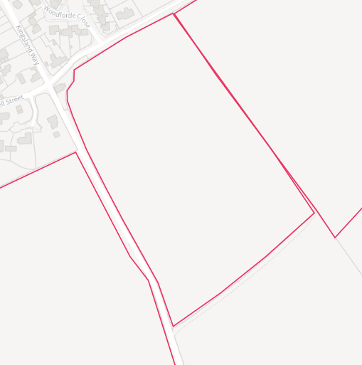
Initial Observations: The historic route of Ashwell Street which is part of the Icknield Way and lies within the Conservation Area forms the northern boundary of this parcel and currently provides a robust, heavily defined boundary to the settlement at this point. The parcel comprises a single field of arable land that is actively farmed and reads as part of the wider countryside.

The parcel occupies a ridge of higher ground that rises from approximately 65m AOD at Ashwell Street, on the northeast corner of the parcel, to 75m AOD in the centre of the parcel. The land then gently falls to the southeast which further reinforces its relationship with the wider countryside.

No apparent Biodiversity objection

No apparent objection on Flooding grounds

Suggest objection on Heritage grounds The section of Ashwell Street on the site’s northern boundary is a relic of the medieval three-field system and an historic boundary that maintains the village’s integrity. In its current unmade state, is an important contribution to village character. Development would undermine the historic settlement pattern of Ashwell and breach the historic route of Ashwell Street.

Suggest objection on Highways grounds as Kingsland Way is a narrow single track rural road which leads into the historic core of Ashwell. Connection southward to the A505 is compromised by the narrow road with poor sight lines. It does not have the capacity to support such a development, either for vehicles or pedestrians, and similarly the highways infrastructure in the village would not be able to accommodate the scale of development proposed. The location is heavily reliant on car usage to Ashwell & Morden station so not consistent with sustainability objectives.

Suggest objection on Infrastructure grounds. The current primary school does not have the spare capacity and cannot be extended further on its site to provide the education needs of the extra population. Significant upgrades of water supply and sewerage treatment may be required.

Suggest objection on Cumulative Impacts because if this development were to come forward with any other development on this side of Ashwell it would harm Ashwell’s historic character.

Conclusion: Suggest objection as the location and scale of development would result in significant harm to the character of the village and have a disproportionate impact on the wider landscape and historic route of Ashwell Street. The core transit routes through the village would not be able to sustain the extra vehicles arising out of such a large development. Current village facilities could be overwhelmed by additional population from such a significant development. Development on this parcel would conflict with the NHDC Landscape Character Area Assessment 224 which was adopted to preserve and protect the North Baldock Chalk Uplands in and around Ashwell.

Land to the west of Station Road, Ashwell, SG7 5LT | 48970 |  | 7.09 ha | 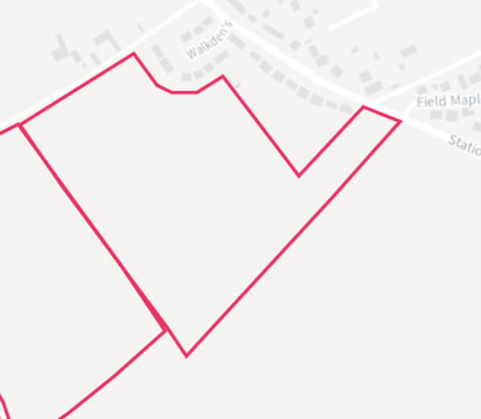
Initial Observations: The parcel comprises a relatively large field and a narrow band of farmland. It sits above the Walkdens development to its East. The northern boundary borders the historic route of Ashwell Street which is part of the Icknield Way and lies within the Conservation Area with the eastern corner providing a link to Station Road, with the recently completed development of Senuna Park on the opposite side of the road.

No apparent Biodiversity objection

No apparent objection on Flooding grounds

Suggest objection on Heritage grounds as development would harm the historic character of the village which is principally aligned along West End, High Street and Lucas Lane. The section of Ashwell Street on the site’s northern boundary is a relic of the medieval three-field system and an historic boundary that maintains the village’s integrity. In its current unmade state, is an important contribution to village character. This parcel also includes a Scheduled Neolithic Monument Field with a highly significant archaeological plot located just behind the housing cul-de-sac ‘The Walkdens’. It sits in the direct angle between Ashwell Street and Station Road. This agricultural field contains the buried remains of the Late Neolithic Class II henge, the elongated long enclosure (long barrow), and five Bronze Age ring ditches.

Development on this parcel would also significantly encroach on open farmland and intrusively overlook the ‘Walkdens’.

Suggest objection on Highways grounds. The location is heavily reliant on car usage to Ashwell & Morden station so not consistent with sustainability objectives.

Suggest objection on Infrastructure grounds. The current primary school does not have the capacity and cannot be extended further on its site to provide the education needs of the extra population. Significant upgrades of water supply and sewerage treatment may be required.

Suggest objection on Cumulative Impacts, the lack of any defining features on the southern boundary and the scale of development proposed would not only harm the character of the village but would also have a disproportionate impact on the neighbouring landscape.

Conclusion: suggest objection as the location and scale of development would be discordant with the character of the village and have a significant impact on both the parcel itself and the wider countryside. The core transit routes through the village would not be able to sustain the extra vehicles arising out of such a large development. Current village facilities could be overwhelmed by additional population from such a significant development.

Land to the south and east of Senuna Park, Station Road, Ashwell, SG7 5QF | 49023 |  | 2.95 ha | 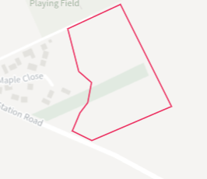
Initial Observations: This parcel of land breaches the heavily vegetated boundary which separates the recently completed Senuna Park development from the neighbouring countryside. The parcel is actively farmed and reads as part of the wider countryside.

No apparent Biodiversity objection

No apparent objection on Flooding grounds

Suggest objection on Heritage grounds as the development would be at odds with the character of Ashwell which is essentially a linear village which extends in depth from West End, the High Street and Lucas Lane.

Suggest objection on Highways grounds. The location is remote (c. one mile or more) from key village facilities (School & Surgery) and so heavily reliant on car usage to the village centre and to Ashwell & Morden station so not consistent with sustainability objectives.

Suggest objection on Infrastructure grounds. The current primary school does not have the capacity and cannot be extended further on its site to provide the education needs of the extra population. Significant upgrades of water supply and sewerage treatment may be required.

Suggest objection on Cumulative Impacts, as development on the parcel would narrow the gap between Ashwell and the freestanding permanent caravan park at Shire Close. It would also combine with the existing, recent, development of Senuna Park to create a dominant urbanising estate of modern housing on the approach to the village with its characterising historic housing.

Conclusion: suggest objection as the location and scale of development would be discordant with the character of the village and would result in harm to the parcel itself and the neighbouring countryside.

 |  | Commercial
Land west of Hare Park Farm, Ashwell, SG7 6SL (Site 9) | 49036 | Employment / Data centre | 28.01 ha | 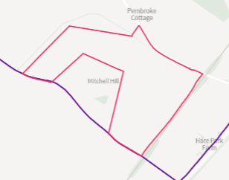
Initial Observations:

This parcel would be accessed from the single track rural Kingsland Way/ Slip End Road and lies some 2+ miles to the East of Ashwell Village. Currently actively farmed fields the land rises to the south away from the access road. Any development would be clearly visible from the access road.

No apparent Biodiversityobjection

No apparent objection on Flooding grounds

No apparent objection on Heritage grounds

Suggest objection on Highways grounds. The location is remote from all Ashwell village facilities and Ashwell & Morden station. There is no footpath and no local facilities so totally reliant on car usage to Ashwell village and to Ashwell & Morden station. Usage of the A505 for access to Slip End Road poses safety risks that Highways are aware of. So the parcel is not consistent with sustainability objectives.

Suggest objection on Infrastructure grounds. Whether the parcel is offered for a data centre or housing major infrastructure investment would be required to support the development.

Conclusion: Suggest strong Objection as the location is totally rural and remote from all facilities and is heavily vehicle dependent and not suited to the current access roads. Major infrastructure is likely to be required to support any development whether a data centre or residential.

Summary

The 8 sites offered within or immediately bordering the current Ashwell Village Settlement Boundary which are being promoted as potential residential sites total 46 hectares. At medium density of 35 dwellings per hectare that could, at maximum development density, translate to an extra 1,600 dwellings increasing Ashwell Village to some 2,500 dwellings (up from the c. 900 currently).

However, typically 35 dph would be net density for medium density housing and it is normal to have parts of sites not developed, for example, for green infrastructure, Suds basins etc. Therefore, at a strategic level, a gross density of 25 dph is often used, which would result in 1,150 dwellings.

At current levels this unique and historic 1000+ year old anglo-saxon farming village with natural chalk Springs, Grade One listed St Mary’s Church, over 70 Grade 2 listed houses, is vulnerable to over development:

- Heritage & Character: The village lies in the valley of the North Baldock Chalk Uplands to the South and is currently hidden as one approaches from the south on any of the routes. The first evidence of habitation is the sight of St Mary’s Church tower but one doesn’t see the residential dwellings until reaching Ashwell St which forms part of the ancient long distance Icknield Way which has historically acted as the natural physical boundary to the village and still forms the Southern Settlement Boundary. From a distance the foreground is actively farmed agricultural fields with only green fields seen in the distance. Any further development to the South further uphill would forever change this unique setting and permanently damage the historic character and Conservation Area of the village and its heritage values.

- Transport: The linear village relies on 2 parallel routes through its east/west centre and 3 routes, 2 of which are narrow rural routes crossing from north to south. The east/west routes through the centre contain many dwellings built up to the footpath or road with no off road parking. Car parking takes place on one side of these roads typically reducing traffic to single file. The roads are already prone to congestion with stationery traffic, and real problems for usage by farm vehicles and emergency vehicles.

The village lies 2 miles from Ashwell & Morden Station with a footpath that only extends to the Cambridgeshire boundary, some ½ mile from the station. Significant levels of commuters use the station but the vast majority by car most of which are unsuitably and unsafely verge parked lining the approach roads for several hundred metres. Being a rural village car usage is seen as essential, and so additional housing is not environmentally appropriate or sustainable.

- Infrastructure: There is currently evidence of low water pressure, requirement to tanker in supplies of water, and sewerage overflow. The primary school has reached its PAN and has no expansion capacity. Significant further development would require an additional Primary School and potential upgrades to water supply and sewerage disposal.

- Housing Need: Neither public consultations or research for the Ashwell Neighbourhood Plan or the CDA Herts Housing Need Survey identified a need for more than modest development prioritised for predominantly 1 or 2 bedroom dwellings.

For the above reasons only one brownfield site (48865) is suggested for supported for development with the other seven sites suggested for objection for one or more reasons.

Site 49036 put forward for a Data Centre lies remotely at the very edge of the Parish and is felt to be unsuitable for Transport and Infrastructure reasons and is suggested for objection on those grounds.
08 November 2026

Third Draft on observations of promoted sites in Ashwell Parish
Prepared by Clive Self on behalf of Ashwell Parish Council, with edits by Norton Mahy

PotentialParsihSiteRevC261108.docx

